Food Express application

Business Requirements Document

Project: Food Express Web Application

Author(s): Tharun Donapati, Deva Nimmagadda, Asma Batoo Lalamiah, Venu yada

Table of Contents

**1.** **Project Overview** 3

**2.** **Document Information** 3

2.1 Audience 3

**3.** **Business Opportunity** 3

3.1 Project Overview and Background 3

3.2 Current State Analysis 4

3.3 Future State Objectives 4

3.4 Business Domain Model and Stakeholders 4

**4.** **Business Requirements** 4

4.1 Details of Business Requirements 5

**5.** **Non-Functional Requirements** 6

**6.** **External Data Feeds** 7

**7.** **Business Risks** 7

# **Project Overview**

* This document describes the business/user requirements for the Food Express applications that will provide the basis for the following project activities:
* Introducing business/user requirements
* Creating test plans and test specifications
* Identifying stakeholders
* Devising solutions to project tasks
* Produce an application that will enable users to order food directly from the food retailors
* Determining when the project is complete
* Assessing the degree to which the project succeeded

# **Document Information**

## 2.1 Audience

|  |  |  |
| --- | --- | --- |
| Advertisement | Finance Department | Partner/Investor |
| Food | Retailors | Partner/ Investor |
| Delivery Companies | Delivery Department | Partner/Supplier |
| Payment Merchants | Payments Processing Department | Partner/Supplier |
| Customers | Orders & Delivery Department, Customer’s Service Department | Web Application Users |
|  |  |  |

# **Business Opportunity**

## 3.1 Project Overview and Background

The main objective is to develop an application that will allow users to order food from a variety of restaurants available on the application. Users may personalize their orders, add other foods to the basket, and complete the purchase. Users have access to subscriptions via which they may sign up for speedier deliveries and other discounts. Users may review the restaurant based on their experiences and offer feedback.

## 3.2 Current State Analysis

We don't have as much time to spend outside these days because of our busy schedules. This is where online food delivery platforms come into play, allowing customers to order food online and save time. People may select the restaurants that are most suited to them from a large selection offered on a single platform. Additionally, finding decent restaurants has become quite difficult these days; however, the reviews and ratings of restaurants that are available on the application make it very simple for users to identify the best ones.

## 3.3 Future State Objectives

The objective is to create the web application that will be able to compete in the very crowded marketplace of food delivery application. The web application will offer a customer to find a wide range of local restaurants online and allow users to select and order the food items online quickly by saving time and money.Customers will gain value from the application due to the price, speed, convenience, efficiency and friendly services offered.

## 3.4 Business Domain Model and Stakeholders

|  |
| --- |
| **Stakeholders** |
| Food Retailers |
| Customers |
| Food Distributors |
| Product Development Team |
| Finance Group |
| Customer Support Group |
| Advertisement Group |
| Advertisement Agency |
| Banks |
| Credit Card Vendors and Apple Pay/Google Pay |

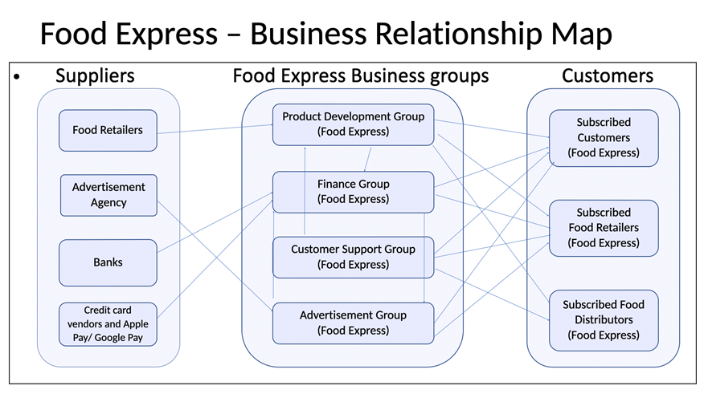

# **Business Requirements**

The primary users of the Food Express application will be able to create the account and subscribe to various subscription plans that will indicate the number of items they will receive in each order. The portal will provide customers with a user-friendly interface that will allow them to search for the local restaurant or desired food item, select the items and place an order. The application will allow the customers to add comments and reviews to the order. The user will also be able to skip the deliveries without cancelling the subscription, allowing the company to keep the customers without making them pay when they want to take a break, allowing Food Express to generate future profit.

## 4.1 Details of Business Requirements

* + 1. **Product Development Department**
       1. Ability to log in
       2. Ability to generate ads on the application
       3. Ability to maintain content on application
       4. Ability to add restaurants on the page
       5. Ability to create/manage subscription plan
    2. **Finance Department**
       1. Ability to log in
       2. Ability to process the plan subscription payments
       3. Ability to process food retailer’s payments
       4. Ability to process food distributors payments
       5. Ability to process Advertisement group payments
    3. **Advertisement Department** 
       1. Ability to log in
       2. Ability to Manage add content
    4. **Customer Support Department**
       1. Ability to log in
       2. Ability to update the open ticket as closed or resolved
       3. Ability to provide the customers with ticket resolution
    5. **Subscribed Customers requirements**
       1. Ability to create/update an account
       2. Ability to log in
       3. Ability to update payment details
       4. Ability to opt/terminate the subscription plan
       5. Ability to add food items into the cart
       6. Ability to place orders
       7. Ability to rate the product/restaurant
       8. Ability to search restaurants/food items
    6. **Subscribed Food Retailers requirements**
       1. Ability to login
       2. Ability to accept orders from customers
       3. Ability to update the status of the order
       4. Ability to update the availability of the restaurant
    7. **Subscribed Food Distributors requirements**
       1. Ability to login
       2. Ability to accept/reject orders from food retailers
       3. Ability to update the order delivery status

# **Non-Functional Requirements**

|  |  |
| --- | --- |
| **Category** | **Requirements** |
| **Usability** | The application GUI will provide a user-friendly intuitive design with all the features clearly displayed for the user |
| **Usability** | The application navigation will be self-explanatory by clear and concise descriptions and names of each section, as well as features will be clearly evident by proper location and naming |
| **Usability** | Accessibility will be supported for the disabled users as well |
| **Performance** | The application will be supported on different operating systems and browsers, and should not impact the user’s system capabilities |
| **Performance** | The application will be available for 24/7 without any interruptions, and regular maintenances will be scheduled to support the application |
| **Performance** | The application will support the concurrency where the users will be able to simultaneously browse the app, login & subscribe, make payments, shop the products |
| **Performance** | The application will have short response time to all requests and all the features should be available and not impacted by latency |
| **Security** | The application will be using the automated daily & weekly audits to detect the vulnerabilities. |
| **Security** | The application will use HTTPS protocols for any data exchanges, enforced TLS for all the email communications, and other encryptions that will be maintained on the server |
| **Database** | The application will be using the MySQL database |
| **External System** | The application will be able to interface with the external data feeds from and to payment merchants, ad agencies, social media websites, etc… |

# **External Data Feeds**

* **Payment Gateway System**

Enables the customers to pay for the plan subscriptions, and retail merchandise that are not part of the subscription plan by processing the payment by authenticating and charging the credit cards or other payment means.

Enables the customers to receive the refunds in case the order got lost or there is an issue with the products in the order by processing the refunds by crediting back the funds.

* **Map system**

Use location services to locate nearest restaurants

Useful for tracking the ongoing orders

* **Ads Platform System**

Food express collects the user cookies to push notifications advertisement method

Inputs from the google location services of the user will be used to suggest the local restaurants

# **Business Risks**

Food express targets a mass market and is constantly vulnerable to many regulatory bodies and reviews. The company’s business is directly proportional to our restaurant partner’s service quality, yet the company needs to align the internal groups to meet the mass market demands in a smooth manner. Even the major giants like Doordash and UberEATS faced a heavy backlash from the public with lawsuits over the key areas of service. The company is not just responsible for customer satisfaction but also for delivery and restaurant partners' satisfaction because these two are responsible for the company image in the market. Major key areas where the company needs to strengthen its policies are Food quality, Food tampering, Platform fee, Customer service and privacy.

Though food quality is something that depends on the restaurant partner still the company is responsible for it, so to avoid such events the company needs to set a standard quality for restaurant partner and polices for customers refund requests. Food tampering rate is another popular negative marker for food delivery companies and the policies responsible for these should be preventive of such actions. Platform fee is one of the major revenue sources for the company which is charged both to restaurant partners and subscribed customers, recently major food delivery giants faced a class actions suit regarding the platform fee levied on the restaurant partners, so the policies around this area are highly prioritized and needs to be improvised regularly depending on the market. Customer service is the face of the company and the prime factor in staying competitive so the internal group responsible should be capable of handling complicated situations. Lastly Customer’s data and privacy should be protected at any cost because cyberattacks are one of the constant threats for the company. To conclude, the company should focus on the above key areas while designing the policies to stay competitive in the market.